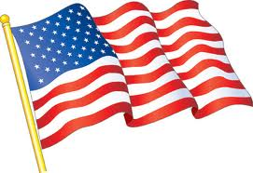
Flags Over Liberty Hill
Support the Liberty Hill Lions Club and show your patriotism!
For a yearly donation of $75, a 3’ x5’ United States Flag will be placed in front of your home or business on the following holidays:
- Martin Luther King Day
- Presidents’ Day
- Memorial Day
- Flag Day (June 14)
- July 4
- Labor Day
- Veterans Day
- (In case of rain, Patriots’ Day, September 11, will be the make-up date).
Donations support the following local, state and national charitable work: LISD scholarships, LISD eye exams and eyeglasses; Lions Foundation Park; Texas Lions Camp in Kerrville, Texas; Leader Dog Program; and world-wide eradication of river blindness and measles.
Name: ________________________________ _________ Phone # _______________________________________
Address: ____________________________________ business or residence (circle one)
____________________________
Email address: _________________________________________
*Initial installation of the flag may involve a pvc tube sunk into the ground and marked with an orange cap at the front of your property nearest the road access. You may be contacted about installation issues by a local Lion.
For more information contact Susan Hopper shopper8707@hotmail or 512-966-6019
Make checks payable to: Liberty Hill Lions and mail to: 285 Quarterhorse Drive, Liberty Hill, 78642 or go online at https://www.pledgereg.com/flags-over-liberty-hill to pay by credit card.
For more information on the Liberty Hill Lions, visit us at www.lhlions.org

